MANUSCRIPT TITLE

Author¹, Author ², Author ³
¹Assistant Professor
Affiliation, India
Orcid: 0000-0002-xx7-0486
²Associate Professor
Affiliation
ORcid: 0000-0002-5502-XXX
³Professor
Affiliation
ORcid : 0000-0002-XXXX-7887 Password
Corresponding mail:

Received: 202X | Revised: 202X | Accepted:+ Published: 202X

ABSTRACT
BACKGROUND AND OBJECTIVE: The majority of the fireworks used in India are produced at Sivakasi, a town in Tamil Nadu's Virudhunagar district. Handling multiple chemicals manually is part of the manufacturing process for fireworks. Consequently, the fireworks industry is regarded for being quite dangerous. The majority of earlier studies emphasised risky behaviours and harmful environments and found that human fault was the primary cause of accidents.
METHOD: For a variety of applications, support vector machines (SVM) are frequently employed as superior classifiers. The correct parameter tuning determines the accuracy of the support vector machine classifier that is built. Grid search has become one of the most widely used methods for determining parameters. In order to determine the actual working situation and provide management with advice for preventing accidents, fires, and explosions that could result in worker fatalities, this study looked at the safety culture among workers in the fireworks sector. Due to the Sivakasi atmospheric conditions, this prediction uses values from prior accident data. The suggested method advances the objectives of performance improvement and global optimization, which primarily involve the following tactics.
FINDINGS: Initially, employing the initialization group for opposition-based learning A novel explosion amplitude method is also suggested for the best fireworks. Additionally, the elite opposition-based learning is employed for the optimal individual and the adaptive t-distribution mutation is utilized for non-optimal people. Lastly, a new collection method called Disruptive Selection was suggested to shorten the algorithm's operating time related to FWA.
CONCLUSION: Researcher use the CEC2013 standard parameters in our model and evaluate the proposed algorithm Improved Fire Work Algorithm against Firework algorithm, SPSO2011, dynamic Firework Algorithm, and Exposed Fire Work Algorithm. The outcomes demonstrate that the suggested method performs better overall on the test functions.
Keywords: Parameter, safety measures, firework industry, support vector machine, health.
NUMBER OF REFERENCES  15 (Not less than 30) | NUMBER OF FIGURES  9 (Not more than 10) | NUMBER OF TABLES  1 (Not more than 10)
RUNNING TITLE: Fire Safety Precaution With Support Vector Machine
INTRODUCTION
Numerous academics have suggested the support vector machine (SVM) as a supervised machine learning technique. SVM is now successfully and widely used for a variety of classification issues in a number of scientific fields. To enhance the classification for the OCR of mathematical documents, support vector machines were applied. A support vector machine model based on textural features was created to distinguish between brain metastases and radiation necrosis. The SVM parameter tuning problem is a challenging optimization problem that calls for extensive computation. Over the past two decades, swarm intelligence algorithms and other stochastic population algorithms have been extensively explored and applied to difficult optimization issues. Deterministic algorithms cannot solve discrete combinatorial exponential problems or complex optimization problems with a large number of local optima in a reasonable amount of time, but stochastic population methods have proven to be quite effective. Swarm intelligence algorithms simulate groups of straightforward agents with straightforward behaviour. Authors lack brains individually, but when authors work together, authors show a great deal of intelligence and the ability to find better solutions.
When fireworks are used, a number of pollutants are released into the atmosphere, including particulate matter and poisonous gases, which have a greater indirect or direct impact on human health in metropolitan areas than in rural ones. Any developing country must pursue industrial development. India's fireworks industries play a major role in the country's industrial development. It provides a lot of work opportunities for locals in and around Sivakasi, Tamil Nadu. This region is best suited for the production of fireworks due to its year-round dry climate. Sparklers and firecrackers are provided by these industries for all festivals. Throughout the world, fireworks are employed during national and cultural celebrations. About 90% of India's firework production comes from Sivakasi, a city with a sizable female workforce. The majority of these companies are located in rural areas, so the workers there are virtually completely illiterate. Even if every task is performed manually, the employees are still in the dark.
Fireworks pollution has a detrimental effect on a variety of items. It compromises not only the quality of the atmosphere but also the health of all living things. It seriously harms the unfortunate creatures and adds to noise pollution. Therefore, compared to other industries, the accident rate is higher. Metallic objects should be avoided when working with chemicals. Even if the accident rate is high, these sectors recover quickly, meeting 90% of the demand for fireworks items around the world. Sivakasi is therefore referred to as "Mini Japan" (Kutty Japan). Before beginning the manufacturing process, enterprises should do a thorough hazard analysis and evaluation to preserve safety in chemical handling. This was done in an effort to lower the risk by implementing effective control mechanisms. Fireworks have a variety of negative health effects, including the development of eosinophilic pneumonia from firework smoke inhalation, asthma from barium-rich aerosols, thyroid gland damage from perchlorates, and reduced visibility due to the formation of opaque clouds.
However, the reality is that fireworks significantly increase local air pollution levels. These toxins can linger for days or hours at a time, putting your neighbours and you at risk for long-term health repercussions. The batch process must diagnose the fault patterns when errors are found. Currently, support vector machines and contribution graphs are the two most used diagnostic techniques (SVM). SVM is receiving more attention for error identification in batch processes since it produces impressive results. This strategy, which combines the sliding time window with SVM to enable batch process problem diagnostics, calls for frequent model modifications and a preset sliding window duration. Additionally, firecrackers seriously endanger the health of all living things. In addition to other things, it causes respiratory issues and hormone problems. Additionally, it affects a person's mental health. The intense noise levels increase anxiety and lead to panic attacks. It results in sleep loss in people and hyperventilation as well.
Zhang & Min (2020) For the nonlinear and multi-phase characteristics of batch processes, a self-adaptive multi-phase batch process fault diagnosis approach is suggested. The core entropy and similarity of the angular structure are constructed before the process data is mapped into a high-dimensional feature space in the kernel entropy component analysis (KECA) approach, which is the initial stage in achieving multi-phase adaptive partition.
Indumathi et al (2022) As industrialisation grows around the globe, occupational health risks are becoming more and more common. To produce light, colour, and sound, hazardous chemicals are employed throughout the whole manufacturing process of fireworks in the fireworks industry. The production of pyrotechnics frequently requires the handling of hazardous chemicals by people, which is a requirement in all industrial operations where workers come into close contact with dangerous substances that could cause illness to health.
Wang & Dan-dan (2018) As industrialisation grows around the globe, occupational health risks are becoming more and more common. To produce light, colour, and sound, hazardous chemicals are employed throughout the whole manufacturing process of fireworks in the fireworks industry.
Nallathambi & Indumathi (2022) The Feed-Forward Back Propagation (FFBP) with the Levenberg-Marquardt function has been utilised to train the network in the creation of the ANN model with hidden layers of 5 and 10. The performance accuracy of both hidden layers is evaluated and compared to that of several models, such as the Support Vector Machine (SVM), Random Forest (RF), and K-Nearest Neighbor (K-NN).
Li & Ling-Ling (2020) Wind energy is unpredictable and irregular in its generation because of this. The integration of huge amounts of wind power has an effect on the stability of the overall power system. It is simpler to use wind energy, the quality of the power supply is improved, and the grid is kept stable with accurate wind power forecasting. A hybrid prediction model that combines wavelet decomposition, support vector machines, and an improved atom search technique is created to estimate wind power output.
Lee & Pei-Hsi (2022)To obtain the appropriate feature set, the observation window might be divided using spectral clustering. Multiple SVM classifiers are employed to find CCPs. Utilizing metrics like recognition accuracy and average runtime, our proposed method's ability to identify CCP is verified (ARL). Our proposed approach generally outperforms the Shewhart chart and the EWMA chart with run rules in terms of the recognition effectiveness of the majority of CCP kinds, according to comparison studies.
Zhang & Min (2020) The kernel function settings have a considerable impact on the precision of mixture CCPs recognition in the MSVM classification approach. As a result, it is advised to select the classifier's two-dimensional parameters using the fireworks technique. Performance of the proposed approach is evaluated against well-known genetic algorithm and particle swarm optimization methods. Results from simulations demonstrate that the proposed technique can increase recognition accuracy while also significantly cutting down on running time.
Tuba et al (2018) The p-median problem is generally applicable in operational research and supply chain management. It has been established that the p-median problem is an example of an NP-hard problem and has been characterised in a variety of ways across the literature. In this research, a new swarm intelligence system called the bare bones fireworks technique is proposed to solve the capacitated p-median issue. This method is the most recent iteration of the fireworks algorithm. Using benchmark datasets with varying p values, the proposed method is tested. The proposed technique generated results that were competitive and had potential for improvement when its performance was compared to that of other methods discovered in the literature.
Fenten et al (2018) Accurate weather forecasts are crucial since the agricultural and industrial sectors rely substantially on weather conditions today. It is also used to generate information and predictions about natural disasters. Weather forecasting is the process of selecting the optimal values for weather parameters and, additionally, predicting future weather conditions based on these variables.
Singla et al (2020) SVMs are flexible learning models that can be used for both regression and classification. Several authors have effectively used SVM in a range of fields. Despite the ongoing expansion and development of machine learning, SVM has been demonstrated to have a number of limitations.
Shafiee et al (2021) Investors, companies, and banks are now more interested in the topic of accurate bankruptcy forecast evaluation due to the significance of firms' bankruptcy prediction (determining credit risk). To find new mathematical approaches that can provide a higher fit rate for this prediction, more investigation and algorithm fit comparisons are required.
Strumberger et al (2018) The "bare bones" approach has been revised and streamlined using the fireworks metaheuristic. According to the literature research, this approach to overcoming the difficulty of planning an RFID network has never been employed previously. The well-known hard optimization problem of RFID network planning is one of the most significant challenges in the deployment of the RFID network.
Tuba & Eva (2019) Machine learning algorithms are used in a wide range of applications, hence it is crucial to create faster, more accurate algorithms. Numerous proposed methods have been developed to address the categorization problem, one of the most common machine learning issues. Regardless of the classifier being used, the feature set chosen has a substantial impact on classification accuracy. Because the quality of the classification depends on the features, feature selection is a critical step in machine learning.
Owolabi et al (2018) Laser-induced breakdown spectroscopy, or LIBS, is an excellent technique for analysing both solid and liquid samples. More precise estimation of the constituents' concentrations in the test sample is not without its problems, though. To address this challenge, the first hybrid support vector regression (SVR) and extreme learning machine (ELM) fusion is given. The Extreme Learning Machine (ELM), a non-linear chemometric method, has the inherent capacity to mimic any non-linear connection describing laser-induced plasma. However, over-fitting reduces the spectroscopic regression accuracy of ELM.
Fang & Heping (2022)The recently developed arithmetic optimization algorithm (AOA), which has been utilised to address different practical optimization difficulties, simulates the addition, subtraction, multiplication, and division distribution properties of the basic arithmetic operations. However, it has been found that the AOA suffers from inadequate exploration and premature convergence to inferior solutions, especially when employed to address issues involving multi-dimensional optimization.
PROPOSED METHOD
Manufacturing Process of Fireworks
A separate manufacturing shed is used for the production of the fireworks goods seen in Fig. 1. The minimum dimensions for industrial sheds are those specified in the factories act . If the manufacturers adhere to these guidelines, then accidents caused by dangerous working circumstances can be greatly minimised, and if the employees are trained in chemical handling safety, then accidents caused by unsafe acts can also be decreased.
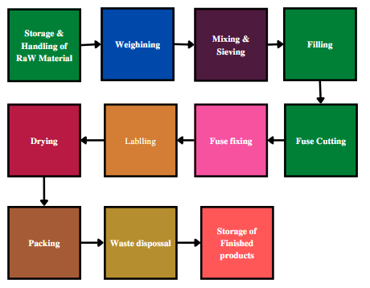
Fig. 1 Firework industries' procedures
Pyrotechnics' potential risks
Each and every chemical used in the fireworks industry is dangerous. Fuel and an oxidising agent are combined to create fireworks. As a result of the workers' ongoing exposure to toxins, there may be health repercussions. Toxic discharge, fire, and explosion are the primary risks associated with the fireworks industry. Fire is the main danger here, as it can cause both property loss and human illness. Another major risk that arises in the fireworks industry is static electricity. Using a wooden plate, chemicals like fuels, oxidizers, and igniters are manually blended. Sulfur dioxide, carbon dioxide, carbon monoxide, nitrogen oxide, and other pollutants released by firecrackers have been linked to health issues. When crackers are consumed at festivals, the environment becomes highly hazardous.
Accidents' root causes
This study examined the factors that lead to accidents in the fireworks industry. Workers in the fireworks industry provided information that was gathered and analysed using a factor matrix. This demonstrates unequivocally that these five criteria account for the majority of incidents in the fireworks sector. According to this, the majority of mishaps happened when making elegant type. In this process, water and chemicals are combined to create sludge. The slurry should be kept in a properly ventilated place after preparation to prevent heat buildup, but if these precautions are not taken, there is a risk of fire mishaps. discovered the fatalities from the explosion of gunpowder in the fireworks factory. When it explodes owing to unidentified ignition sources, the impact on the employees is considerable, resulting in significant injuries or fatalities. When compared to other chemicals, the gun powder explosion has an extremely high fatality rate. The government organisation also examined the causes of fireworks accidents, as shown in Fig. 2, where 36% of the reported incidents were primarily caused by friction.
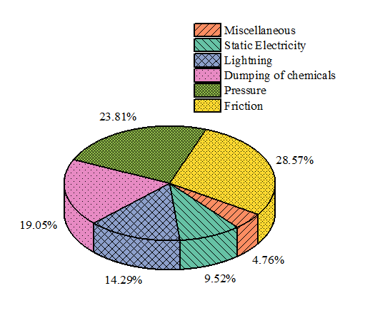
Fig. 2 Causes for accidents

Support Vector Machine
One of the newest and most popular binary classifiers is the support vector machine (SVM). The SVM's main goal is to identify a hyperplane that divides instances belonging to two different classes. Each instance is identified with the appropriate class and is represented as a point in space. The hyperplane that divides samples from various classes represented as vectors xi Rd labelled with yi 1, 1, I = 1, 2,..., n, could be stated as follows under the assumption that training data are linearly separable:
(1)
The soft margin is introduced as follows because there are generally more outliers in real-world data than in the hard margin suggested by Equation (1):
(2)

The following quadric programming problem needs to be resolved in order to determine the ideal soft margin:
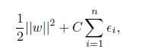 (3)
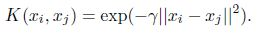 (4)
Usually, cross-validation is used to assess accuracy. Grid search has the drawback of being a local search, making it more likely to become enmeshed in local optimums. Another challenge is determining the search interval. Search intervals that are too long will generate a large number of useless calculations, whereas search intervals that are too short will almost certainly result in the absence of ideal values.
FWA: Firework Algorithm
FWA is used in parameter optimization for the SVM kernel function parameters because it has a high degree of accuracy when resolving non-linear and complex numerical computations. By simulating a fireworks explosion, it can look for the best answer, and more information on the FWA process may be discovered. Consider a system that has no fireworks. The first n places are chosen at random from the solution space. Its fireworks' spark count and explosion amplitude (i.e., xi, 8i = 1, 2, :::n) are defined as
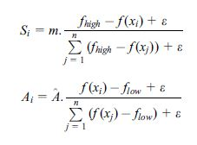
In the current algebra, the best fitness value is referred to as the contemporary minimum by the notation F high, and the worst fitness value is referred to as the contemporary maximum by the notation flow. Figure 3 displays the flow of the algorithm.

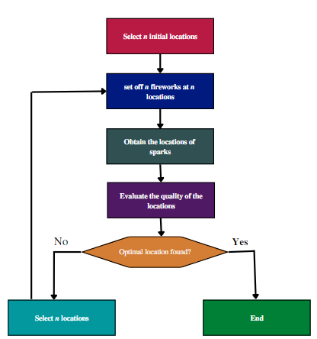

Figure 3. Flowchart for FWA.

Health Risk Assessment for Chemicals (CHRA)
The Chemical Health Risk Assessment (CHRA) was carried out in a chemical research lab with a high exposure level. The duration rating was computed using qualitative observations. The exposure limit for rating 1, the rating with the shortest duration, is 12.5% of the working hours. If you give something a rating of 5, it means that you spend more than 87.5% of your working hours exposed. The substances present were then used to determine the magnitude rating using a separate rating system.
Risk evaluation for health and safety (RASH)
As handling and prolonged exposure to chemicals are involved in the firework industry, RASH may be an appropriate tool for determining the level of risk. Risk was formerly defined as the product of severity and likelihood; however, RASH takes into account both severity and likelihood for both safety and health.
Chi-square calculation
It used a 12-hypothesis Chi-square test to analyse the safety climate in the fireworks industry. The business and the contract employees framed the notion. The Chi square test shows that there is no correlation between the actions taken against the employees and the company/contract workers. All other hypotheses, including those relating to the respondents' education, safety budget, risk level, and opinions on contract work, hold true.
RESULTS AND ANALYSIS
FWA [8], EFWA [10], dynFWA, and SPSO 2011 are compared with IFWA in order to evaluate its performance.
Table 1. CEC2013 test set.
Function Number |  | Function Name | Optimal Value
Unimodal functions | 1 | Sphere Function | -1400
 | 2 | Rotated high conditioned elliptic function | -1300
 | 3 | Rotated bent cigar function | -1200
 | 4 | Rotated discus function | -1100
 | 5 | Different ppwer funtion | -1000
Basic Multimodal Functions | 6 | Rotated rosenbrock,s function | -900
 | 7 | Rotated schaffer's function | -800
 | 8 | Rotated Ackiey's function | -700
 | 9 | Rotated Welerstrass fuction | -600
 | 10 | Rotated grlewank's function | -500
 | 11 | Rastrigni's function | -400
 | 12 | Rotated rastrigin's function | -300
 | 13 | Non-continuous rotated rastrigin's function | -200
 | 14 | Schewefer's function | -100
 | 15 | Rotated schewefer's funciton | 100
 | 16 | Rotated katsuura function | 200
 | 17 | Lunacek bi_ Rastrigin function | 300
 | 18 | Rotated Lunacek bi_ Rastrigin function | 400
 | 19 | Expanded griewank's plus rosenbrock's function | 500
 | 20 | Expanded scaffer's F6 function | 600
Composition functions | 21 | Composition function 1 ( N-5) | 700
 | 22 | Composition Function 2 (N-3) | 800
 | 23 | Composition funciton 3 (N-3) | 900
 | 24 | Composition funciton4 (N-3) | 1000
 | 25 | Composition funciton 5 (N-3) | 1100
 | 26 | Composition funciton 6 (N-5) | 1200
 | 27 | Composition funciton 7 (N-5) | 1300
 | 28 | Composition function 8 (N-5) | 1400

This paper suggests the following four enhancements:
- The population initialization method that uses opposition-based learning
- a new mechanism to modify the ideal fireworks' explosive amplitude.
- The elite opposition-based learning for optimal fireworks and the t-distribution mutation for suboptimal fireworks
- The next generation is chosen using a novel selection approach known as "disruptive selection."
The results of this section's verification of each improvement in comparison to FWA are displayed in Table 2. The FWA stands for the "basic fireworks algorithm," "FWA-I" for the "basic fireworks algorithm with improvement 1," "FWA-II" for "improvements 1 and 2," "FWA-III" for "improvements 1-3," and "IFWA" for "the basic fireworks algorithm with all improvements."
Table 2. Average fitness score and overall rank 1 numbers.
Functions |  | FWA | FWA-1 | FWA-2 | FWA-3 | IFWA
f1 | Mean | -1396.7 | -1396.81 | -1400 | -1400 | -1400
f2 | Mean | 2.3 Χ 10⁷ | 2.21 Χ 10⁷ | 3.62 Χ 10⁵ | 3.39 Χ 10⁸ | 4.03 Χ 10⁵
f3 | Mean | 7.2 Χ 10⁹ | 7 Χ 10⁹ | 6.76 Χ 10⁸ | 4.92 Χ 10⁸ | 1.21 Χ 10⁸
f4 | Mean | 2.18 Χ 10⁴ | 2.13 Χ 10⁴ | 1.33 Χ 10⁴ | 1.47 Χ 10⁴ | -1099.89
f5 | Mean | -997.58 | -997.71 | -1000 | -1000 | -1000
f6 | Mean | -815 | -82.71 | -856.34 | -859 | -872
f7 | Mean | -639 | -646.13 | -614.85 | -528 | -7.9
f8 | Mean | -679.06 | -679.07 | -679.07 | -679.08 | -679.13
f9 | Mean | -565.52 | -566.13 | -566.46 | -566.78 | -576.12
f10 | Mean | -464.8 | -468.12 | -499.63 | -499.7 | -499.978

Comparing Search Curves
Eight functions with significantly different rates of evolution in five techniques were chosen for this paper due to space constraints. The searching curves for eight functions for the FWA, EFWA, dynFWA, SPSO2011, and IFWA are shown in Figure 4. The remaining 20 functions' searching curves are displayed in Figure 4.

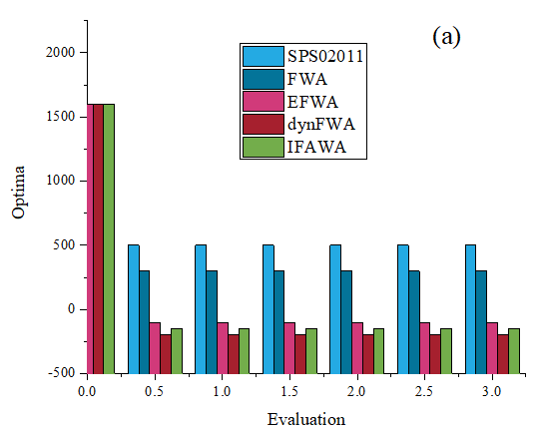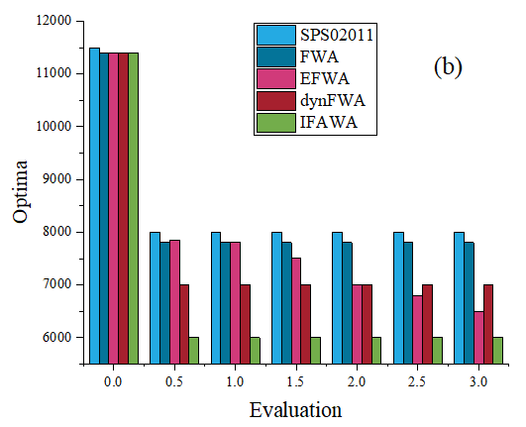
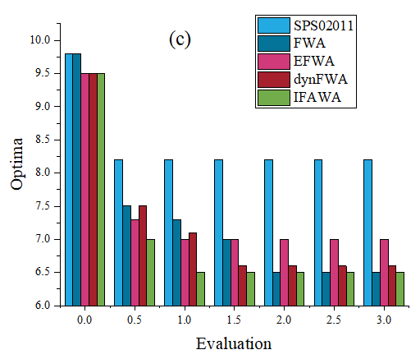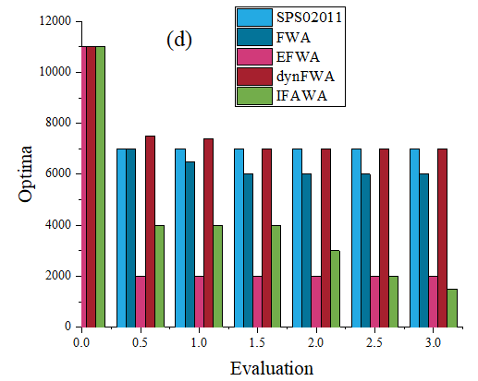
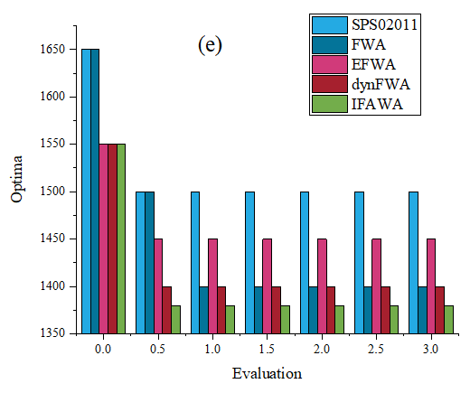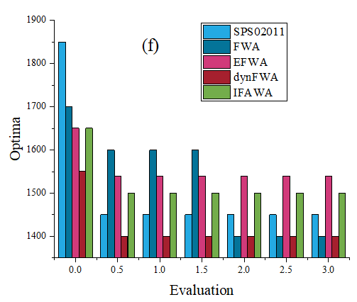
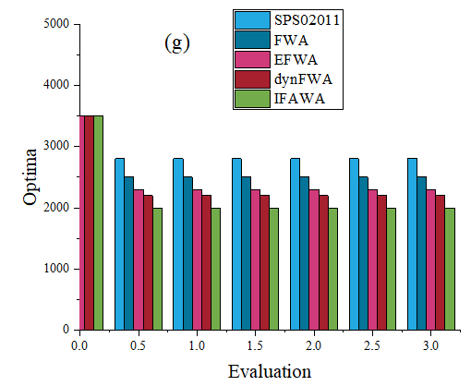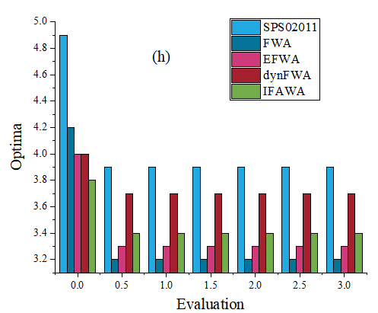

Figure 4. The IFWA, FWA, EFWA, dynFWA, SPSO2011, and searching curves.
Comparison of average rank and average fitness value
Comparing the average fitness value and overall number of rank 1 for FWA, EFWA, dynFWA, SPSO2011, and IFWA is shown in Table 3.
Table 3. Average fitness score and overall rank 1 number
Functions |  | SPSO2011 | FWA | EFWA | dynFWA
f1 | Mean | -1400 | -1396.7 | -1399 | -1400
 | Rank | 1 | 3 | 2 | 1
f2 | Mean | 3.371 Χ 10⁵ | 2.3 Χ 10⁷ | 6.85 Χ 10⁵ | 8.69 Χ 10⁵
 | Rank | 1 | 5 | 3 | 4
f3 | Mean | 2.88 Χ 10⁸ | 7.2 Χ10⁹ | 7.76 Χ 10⁷ | 1.23 Χ 10⁸
 | Rank | 4 | 5 | 1 | 3
f4 | Mean | 3.75 Χ 10⁴ | 2.18 Χ 10⁴ | -1098.9 | -1089.6
 | Rank | 5 | 4 | 2 | 3
f5 | Mean | -1000 | -997.58 | -999.92 | -1000
 | Rank | 1 | 3 | 2 | 1
f6 | Mean | -862 | -815 | -850 | -869
 | Rank | 3 | 5 | 4 | 2
f7 | Mean | -712 | -639 | -627 | -700
 | Rank | 1 | 4 | 5 | 3
f8 | Mean | -679.08 | -679.06 | -679.09 | -679.1
 | Rank | 3 | 5 | 4 | 2
f9 | Mean | -571 | -595.52 | -568.46 | -575.87
 | Rank | 3 | 5 | 4 | 2
f10 | Mean | -499.66 | -464.8 | -515.7 | -499.95
 | Rank | 3 | 5 | 4 | 2

The results from Table 3 show that out of the five algorithms, the total number of rank 1 of IFWA (17) is the best.
Average Run-Time Cost Comparison
Average run-time costs for 28 functions for FWA, EFWA, dynFWA, SPSO2011, and IFWA are compared in Figures 5 and 6.
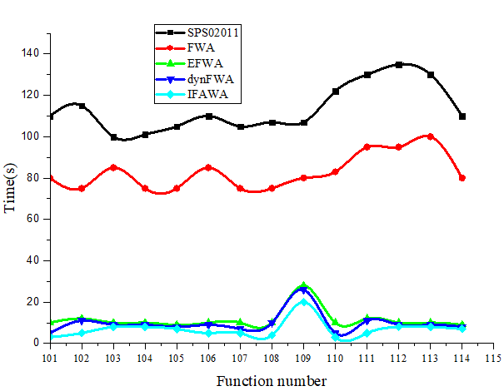
Figure 5. The FWA, EFWA, dynFWA, SPSO2011 and IFWA run-time cost

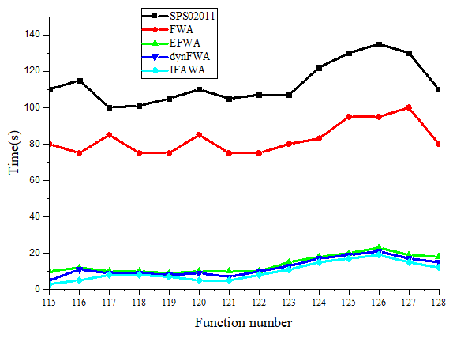
Figure 6. The run-time costs for the FWA, EFWA, dynFWA, SPSO2011, and IFWA (Continued).
The T test's outcome is shown here by the p-value. The "+" represents a 5% significance level rejection of the null hypothesis, and the "" represents a 5% significance level acceptance of the null hypothesis. According to Table 4, IFWA outperformed FWA, EFWA, dynFWA, and SPSO2011 in the majority of functions.

Table 4. T test results of IFWA compare with SPSO2011, FWA, EFWA, dynFWA.
Functions |  | SPSO2011 | FWA | EFWA
f1 | ρ-value | NaN | 0 | 0
 | Significan | - | + | +
f2 | ρ-value | 0.0045 | 1.102 Χ 10⁴⁰⁸ | 5.186
 | Significance | + | + | +
f3 | ρ-value | 7.9152 Χ10-⁹ | 1.352 Χ10⁴⁵ | 0.0666
 | Significance | + | + | -
f4 | ρ-value | 0 | 0 | 4.251
 | Significance | + | + | +
f5 | ρ-value | NaN | 0 | 0
 | Significance | - | + | +
f6 | ρ-value | 0.0141 | 4.73 Χ10⁴⁹ | 4.7756 Χ 10⁸
 | Significance | + | + | +
f7 | ρ-value | 0.4621 | 6.677 Χ10⁴⁵ | 1.9078
 | Significance | - | + | +
f8 | ρ-value | 0.4081 | 0.2895 | 0.0907
 | Significance | - | - | -
f9 | ρ-value | 3.325 Χ 10⁴ | 1.0957 | 1.7148
 | Significance | + | + | +
f10 | ρ-value | 2.006 Χ 10 ⁱ⁰⁹ | 3.799 | 1.247
 | Significance | + | + | +

CONCLUSIONS
This research proposes enhanced fireworks algorithm based on the following examination. Opposition-based learning is first implemented in FWA using IFWA to initialise the population. The lack of explosion amplitude in FWA is also addressed, and a novel explosion amplitude mechanism is suggested.
- In comparison to all other businesses, the fireworks industry is very dangerous. These businesses experience accidents every year as a result of risky behaviours and hazardous surroundings.
- This looked at the manufacturing procedures used in those businesses, potential risks, accident causes, safety analyses using various approaches, and the impact of pyrotechnics in the air. There aren't many works of literature that are devoted to figuring out why accidents happen.
- Given that the majority of workers are illiterate, it can be argued that mandatory safety trainings on safe work practises and chemical dangers will raise workers' knowledge of these issues.
It will be possible for workers to take preventive action at their own workplace before an accident happens by prioritising the risks in various industrial processes. Additionally, human error can be found in every process, and measures for mitigating it can be employed to reduce the likelihood of fatalities. If management provides welfare amenities, safety, and health in accordance with the law, the employees may work in a safe environment.
Competing interests
The authors declare that they have no competing interests.
Consent for publication
Not applicable
Ethics approval and consent to participate
Not applicable
Funding
This research study is sponsored by the institution name. Thank you to this college for supporting this article!
Availability of data and materials
Not applicable
Authors’ contribution
Author A supports to find materials and results part in this manuscript. Author B helps to develop literature part.
Acknowledgement
I offer up our fervent prayers to the omnipotent God. I want to express my sincere gratitude to my co-workers for supporting me through all of our challenges and victories to get this task done. I want to express my gratitude for our family's love and support, as well as for their encouragement. Finally, I would like to extend our sincere gratitude to everyone who has assisted us in writing this article.
REFERENCE:

Zhang, M.; Wang, R.; Cai, Z.; Cheng, W., (2020). Phase partition and identification based on kernel entropy component analysis and multi-class support vector machines-fireworks algorithm for multi-phase batch process fault diagnosis. Trans. Ins. Meas. Cont., 42(12): 2324-2337 (13 pages).
Indumathi, N.; Ramalakshmi, R.; Selvapalam, N., (2022, August). Application of machine learning techniques for an evaluation of hazardous chemical assessment in firework industry. In AIP Conf. Proce., 2520(1): AIP Publishing.

Wang, D. D.; Yang, K..; He, Z. J.; Yuan, Y. Q.; Zhang, J., (2018, December). Application research based on GA-FWA in prediction of sintering burning through point. In Proceedings of the 2018 International Conference on Computer, Communications and Mechatronics Engineering (CCME 2018), Shanghai, China (pp. 22-23).

Nallathambi, I.; Ramar, R.; Pustokhin, D. A., Pustokhina, I. V., Sharma, D. K., Sengan, S., (2022). Prediction of influencing atmospheric conditions for explosion Avoidance in fireworks manufacturing Industry-A network approach. Environ. Pollu., 304, 119182.

Li, L. L., Chang, Y. B., Tseng, M. L., Liu, J. Q., & Lim, M. K. (2020). Wind power prediction using a novel model on wavelet decomposition-support vector machines-improved atomic search algorithm. Jour. Clea. Produ., 270, 121817.

Lee, P. H., Torng, C. C., Lin, C. H., Chou, C. Y. (2022). Control chart pattern recognition using spectral clustering technique and support vector machine under gamma distribution. Com. & Indu. Eng., 171, 108437.

Zhang, M., Yuan, Y., Wang, R., & Cheng, W., (2020). Recognition of mixture control chart patterns based on fusion feature reduction and fireworks algorithm-optimized MSVM. Patt. Ana.s and App., 23, 15-26 (11 pages).

Tuba, E., Strumberger, I., Bacanin, N., & Tuba, M. (2018). Bare bones fireworks algorithm for capacitated p-median problem. In Advances in Swarm Intelligence: 9th International Conference, ICSI 2018, Shanghai, China, June 17-22, 2018, Proceedings, Part I 9 (pp. 283-291). Sprn. Inter. Pub. (8 pages).

Fente, D. N., & Singh, D. K. (2018, April). Weather forecasting using artificial neural network. In 2018 second international conference on inventive communication and computational technologies (ICICCT) (pp. 1757-1761). IEEE (4 pages).

Singla, Manisha, and K. K. Shukla. (2020). Robust statistics-based support vector machine and its variants: a survey. Neural Computing and App., 32.15: 11173-11194 (21 papges).

Shafiee, M., & Fakhari, H. (2021). Evaluation of back propagation-artificial neural network (BP-ANN) fit rate and types of vector machine algorithms in estimating the bankruptcy prediction of companies listed on tehran stock exchange. Turkish Jour. of Com. and Math. Edu., (TURCOMAT), 12(14), 1854-1868 (14 pages).

Strumberger, I., Tuba, E., Bacanin, N., Beko, M., & Tuba, M. (2018, July). Bare bones fireworks algorithm for the rfid network planning problem. In 2018 IEEE Congress on Evolutionary Computation (CEC) (pp. 1-8). IEEE ( 8 pages).

Tuba, E., Strumberger, I., Bacanin, N., Jovanovic, R., & Tuba, M. (2019, June). Bare bones fireworks algorithm for feature selection and SVM optimization. In 2019 IEEE Congress on Evolutionary Computation (CEC) (pp. 2207-2214). IEEE (7 pages).

Owolabi, T. O., & Gondal, M. A. (2018). Quantitative analysis of LIBS spectra using hybrid chemometric models through fusion of extreme learning machines and support vector regression. Journal of Intelligent & Fuzzy Systems, 35(6), 6277-6286 (9 pages).
Fang, H., Fu, X., Zeng, Z., Zhong, K., & Liu, S. (2022). An improved arithmetic optimization algorithm and its application to determine the parameters of support vector machine. Mathematics, 10(16), 2875.

